UC 5 System shall handle loan logic (eligibility, interest, and repayment schedule)

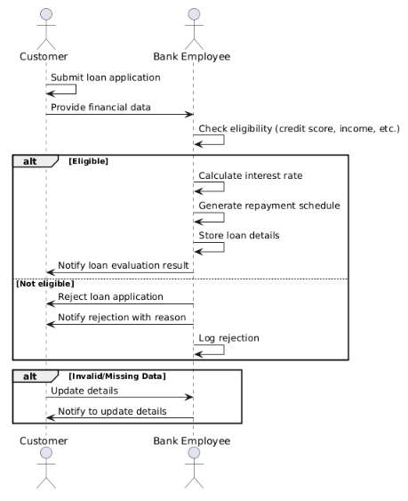

UC 6 Bank employee shall manage and approve/reject customer loan applications.

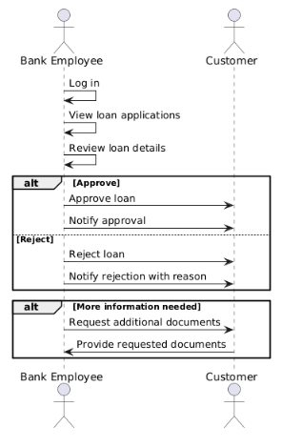

UC 7 Customer shall be able to request a checkbook.

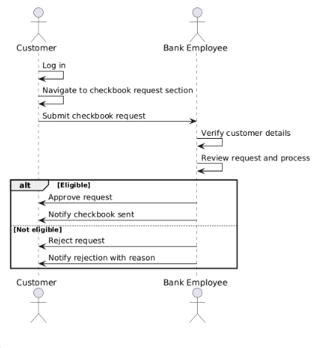

UC 8 Bank employee shall be able to approve or reject account creation requests.

